

NBI

System Development Document

Computer Studies Major Project

Lu Xin

2007

Content Page
NBI 1
Content Page 2
Problem Definition 4
Specifications 4
Design Layout 6
Visual: 6
Database: 7
Menu 7
People 7
Info 7
Java Programming: 7
Data Structures and Files 9
Algorithm 10
Methods: 10
UseProgram: 10
NBILogin: 10
Main Menu: 11
AllPeople: 11
Personal Details: 12
EditDetails: 12
Users: 12
AddUser: 13
GettersnSetters: 13
Messaging: 13
ReadMsg: 14
NewMsg: 14
NewMsg: 14
Print: 15
Search: 15
Status: 15
Rankings: 16
Test Plans 17
Evaluation 19
Future plans 19
Reference 19

Problem Definition

The NBI (National Bureau of Investigation) needs a new secure database which holds the information about all their fugitives and most wanted terrorists. It would hold all the information about the villains such as date of birth, place of birth, physical description and reward for leads etc. This program would require a login and once you have been granted permission, you can access all the FBI top secret files.
I plan on making a login screen first, once username and password have been accepted, the user will then enter in to a screen where a list of options is available such as viewing all the criminals, searching for criminals, and updating them. You will also have the ability to send messages to other users for updates.
This will all be done through the use of Microsoft Access and GUI with Eclipse.

Specifications
All information will be stored in a database created using Microsoft Access. I will contain the following tables:
a) Login information
b) Types of criminals
c) Name of criminals
d) Information of criminals

The program will contain the following items:

Login screen – this is required to gain access to the program, if wrong password given 3 times, program terminates.

Main menu which includes:
Categories: a) Terrorist
b) Fugitive
c) Criminal
Editing and choice of convict’s capture status is also available here.

Search by physical description (i.e. hair colour) or name.

A Rankings page which will rank all criminals according to their reward.

A messaging service which will be used to discuss important topics, and information such as updates of criminals.

Captured / Not Captured section.

Admin can add and delete users.

All info about the convicts will be displayed and editable:
a) Name
b) Date of Birth
c) Height
d) Weight (lbs)
e) Hair
f) Eyes
g) Sex (M/F)
h) Nationality
j) Scars & Marks
k) Crime
l) Reward (USD$)
m) Status of Capture

Log out available.

Design Layout
Send, receive, reply, delete, forward, print, mark as unread.

Visual:

Captured / Not Captured

Users
Add and delete

Login Screen

Categories

Search Physical description, name
Rankings
According to reward
Captured / Not Captured

Terrorist

Fugitive

Criminal

List of people

Set Captured/ Not

Information
a) Name b) Date of Birth
c) Height d) Weight (lbs)
e) Hair f) Eyes
g) Sex (M/F) h) Nationality
j) Scars & Marks k) Crime
l) Reward (USD$) m) Edit info

Database:

Tables: Feilds:
Login: a) Login
b) Password
c) Admin

Menu: a) Type of Criminal

People: a) Name
b) Type of Criminal

Info: a) Name
b) Date of Birth
c) Height
d) Weight (lbs)
e) Hair
f) Eyes
g) Sex (M/F)
h) Nationality
j) Scars & Marks
k) Crime
l) Reward (USD$)
m) Type of Criminal
n) Caught (Y/N)

Messages: a) Message_Title
b) Message_Body
c) Sender
d) Receiver
e) Read
f) Message_ID
g)Urgent

Java Programming:

Login Screen:
The user is required to enter the access code to login to the program. The information entered will be checked with the information in the database to see if it’s correct, if incorrect, you will get a chance to re-enter the password. If the wrong password is entered wrong 3 times, the program will terminate.

Categories:
The user will be able to select the type of criminal they want: fugitive, terrorist and criminal. It will then display the criminals under that category. Information about the villains’ will be displayed such as: date of birth, place of birth, height, weight, hair, eyes, sex, race, nationality, occupation, scars and marks, remarks and reward. You will also have the option to edit all these details.

Subcategories:
Edit: You will be able to edit details about the villain if anything has change.

Search:
Once search is selected, the user will be able to enter in a detail about a physical description and all matching villains will be displayed, similar to selecting by category. Edit and Caught/Not Caught will also be available here.

Rankings:
This will rank all the villains from most wanted to least wanted. The villain with the most bounty for capture will be ranked first, second most ranked second and so forth.

Captured/Not Captured section:
This will group all the convicts into either Captured or Not Captured.

Users:
Here you will be able to add and delete users as well as see the list of users and their passwords if the user is an admin.

Messages:
A messaging service which will be used to discuss important topics, and information such as updates of criminals. You can see number of unread messages in main menu, list received and sent messages, compose and send to more than one user as well as set the urgency of that message, reply to a message, forward a message, print a message, delete a message, set a message to unread and see the urgency of a message.

Back/Quit:
At any stage in the program, you will be able to go back to an earlier stage or logout the program.

Data Structures and Files

Database files: Database.mdb

Java files: AddUser.java
NBILogin.java
MainMenu.java
AllPeople.java
Search.java
Status.java
Rankings.java
Editdetails.java
GettersnSetters.java
Messaging.java
Methods.java
NewMsg.java
PersonalDetails.java
Print.java
PrintPreview.java
ReadMsg.java
Users.java
UseProgram.java

Word Documents: System Development Document.doc
User Manual.doc
Technical Document.doc

Algorithm

Methods:
BEGIN MAIN
Connect to database
Update a table
Fill array with info of all convicts
Test to see if the item entered in a component is a number
SetUser to store Username in a static variable
SetAdmin to store Admin rights in a static variable

END MAIN

UseProgram:
BEGIN MAIN
Application class with LAUCHES NBILogin
END MAIN

NBILogin:
BEGIN MAIN

READ from database usernames and encrypted passwords into arrays DBLogin and DBPass.
Allow user to ENTER in username and password: Login, Password.

CREATE a LOOP to encrypt the password
Convert = value of each character of Password + 2
SecretPass = SecretPass + character of Convert
END LOOP

IF Login BUTTON PRESSED
Compares all logins and passwords to the entered login and encrypted password

IF match found
LAUNCH MainMenu
CLOSE current window
Found set to TRUE
END IF
END WHILE
IF NOT FOUND
WRITE error message
Wrong message counter increases by 1
IF Wrong counter=3
Give a warning for intrusion alert and close the window.
END IF
END ACTION

END MAIN

Main Menu:
BEGIN MAIN
SHOW Frame, Pictures, Labels and Buttons WITH GUI.
IF User is an admin, then Users button is enabled.

IF Fugitive/Terrorist/Criminal/Search/Status/Rankings/Users/Switch User /Messaging/ User Manual/ Button PRESSED

LAUNCH Fugitive/Terrorist/Criminal/Search/Status/Rankings /Users/Switch User /Messaging/ User Manual/ Window
CLOSE current window
END ACTION

IF Logout Button clicked
CLOSE current window
END ACTION
END MAIN

AllPeople:
BEGIN MAIN
SHOW Frame, Pictures, Labels, Buttons, Scroll panes and Lists WITH GUI.

READ Names from database Names Table Alphabetically where type is Fugitives/Terrorists/Criminals

Use DISPLAY method to list the names in a List and see how many messages you have.

IF View Details Button PRESSED
Get name of the selected index
Send the name of the person to PersonalDetails page
Close current page.
END IF

IF Logout Button clicked
CLOSE current window
END ACTION

IF Back Button clicked
LAUNCH MainMenu
CLOSE current window
END ACTION

END MAIN

Personal Details:
BEGIN MAIN
READ in all info from database where NAME = the name sent from the ALL PEOPLES Page.
Display all info in labels

IF EDIT BUTTON PRESSED
Send Person’s Name to the edit program
Close current window
END MAIN

EditDetails:
BEGIN MAIN
READ in all info from database where NAME = the name sent from the Personal Details Page.
Display all info in Text Fields

IF EDIT BUTTON PRESSED
Get new info
Use Update in Methods to update the database of the person
Close current window
END MAIN

Users:
BEGIN MAIN
READ in users info from database
Show users in a list

IF DELETE BUTTON PRESSED
Get name of selected person
Use Update in Methods to delete the person

IF ADD BUTTON PRESSED
Launch AddUser
Close current window
END MAIN

AddUser:
BEGIN MAIN
READ in users info from database

IF ADD BUTTON PRESSED
CHECK IF Passwords are the same and the Username does not already exist
IF TRUE: Use Update in Methods to add new user
Close current window

END MAIN

GettersnSetters:
BEGIN MAIN
Declare all variables for details in the database.
Generate Default constructor and Getters and Setters
END MAIN

Messaging:
BEGIN MAIN
IF Inbox selected
READ in all messages which are sent TO the User.
Display them in a list with subject, SENDER, read and urgency
IF Sent Messages selected
READ in all messages which are sent BY the User.
Display them in a list with subject, RECEIVER, sent and urgency
Hide buttons Set as Unread and Delete.

IF Read Message button pressed
Send the message ID to the ReadMsg class and LAUNCHES it
Closes current window

IF Compose button pressed
LAUNCHES NewMsg class
Closes current window

IF Set as Unread button pressed
Uses the update method in Methods to change the message to unread.

IF Delete button pressed
Uses the update method in Methods to delete message

END MAIN

ReadMsg:
BEGIN MAIN
Reads in all info about the message with that ID number
Displays in labels

IF it is being viewed as a sent message, hide Reply, Forward and Delete buttons

IF Reply/Forward button pressed
LAUNCHES NewMsg window and sets it to reply or forwad

IF Delete button pressed
Uses the update method in Methods to delete message

IF Print button pressed
LAUNCHES PrintPreview page

END MAIN

NewMsg:
BEGIN MAIN
Reads in all info entered by user
Displays a list of all the users to add to the Receivers list.

IF it is set to REPLY or FORWARD, the respected fields will be set values

If ADD Button pressed, checks if the name is already of the Receivers list, if not, then adds it there

If Delete Button pressed, Removes the name from Receivers list

IF Send Button PRESSED
Generates the ID number by adding 1 to the largest ID number in the database
Uses the update method in Methods to create a new message with an ID number

END MAIN

NewMsg:
BEGIN MAIN
Displays all info about the message in a text field
Use the print class to print that text field
END MAIN

Print:
A printing class acquired from www.apl.jhu.edu/~hall/java/Swing-Tutorial/Swing-Tutorial-Printing.html

Search:
BEGIN MAIN
SHOW Frame, Pictures, Labels, Buttons, Scroll panes and Lists.
READ all INFO from database Info Table, store in an Array of records
GET requested search INFO

DO WHILE (SIZE <= total number of records)
IF (REQUESTED INFO = INFO from database)
Add that NAME into a new array
END IF
SIZE=SIZE +1
END WHILE

Use DISPLAY method to list the names in a List.
INTERGER Selection = Get Selected Index
IF (Selection = x)
DISPLAY picture of selected person
DISPLAY all info about person
END IF

IF Edit Button PRESSED
Get new info
Use Update in Methods to update the database of position Selection
END ACTION

IF Logout Button clicked
CLOSE current window
END ACTION

IF Back Button clicked
LAUNCH MainMenu
CLOSE current window
END ACTION
END MAIN

Status:
BEGIN MAIN
READ Fields Names and Caught from Table People
CREATE 2 Lists.

Use DISPLAY method to display a list with all Caught = true and another with Caught = False.

INTERGER Selection = Get Selected Index
IF (Selection = x)
DISPLAY picture of selected person
END IF

IF SetCaught Button clicked
Use Update in Methods to set Caught to TRUE of the selected person in the database
END ACTION
IF SetNotCaught Button clicked
Use Update in Methods to set Caught to FALSE of the selected person in the database
END ACTION

IF Logout Button PRESSED
CLOSE current window
END ACTION

IF Back Button PRESSED
LAUNCH MainMenu
CLOSE current window
END ACTION
END MAIN

Rankings:
BEGIN MAIN
READ all INFO from Table INFO in descending order by Reward
Use DISPLAY method to list the names and rewards in a list.

IF View Button PRESSED
LAUNCHS PersonalDetails with selected persons name
END ACTION

END MAIN

Test Plans
The program will be tested by using the program thoroughly and trying all possibilities to find any error messages.

If a error message is found in the console, a suitable GUI error message will be provide if the users actions can not be met (for example, searching for a name with does not exist, entering a string instead of a number).

Examples:
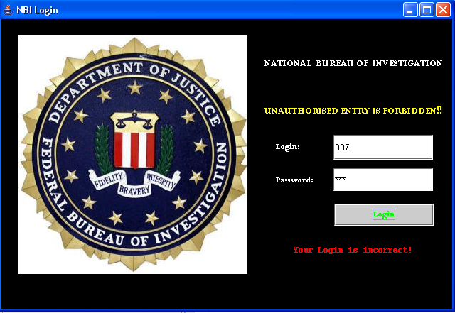
TEST 1: Entering in a wrong Login

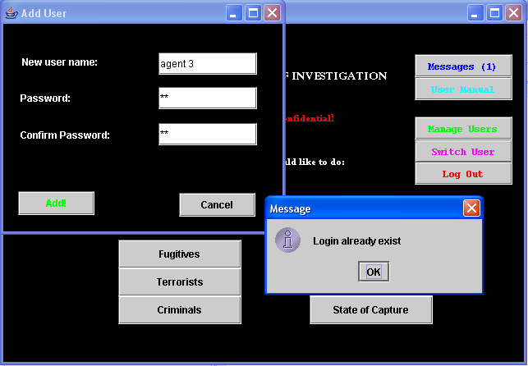
TEST 2: Adding a user which already exists.
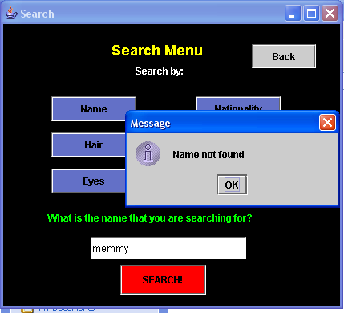

TEST 3: Searching for someone that does not exist.

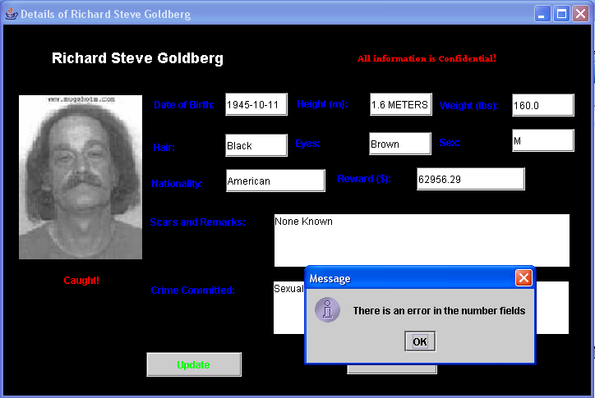
TEST 4: The Height field is not a double but a string.

Evaluation
The process of making this program was one that was long, but enjoyable and a great learning experience. I had experienced many difficulties with the email part of the program of how to make each email unique. I found that the use of parameters for the different methods worked well and especially for the AllPeople.java class. The testing for numbers and returning of an error message if a search was not found was not an easy process. But with thorough testing and thinking, it all worked out in the end.

Future plans
The users will be able to add new convicts and the program will off to add an image to the details. The users will be able to pose topics in a forum to discuss tips of the fugitives and where they might catch them. Make the password encryption more sophisticated.

Reference
A class for printing with acquired from
www.apl.jhu.edu/~hall/java/Swing-Tutorial/Swing-Tutorial-Printing.html.
Much thanks to Mrs Vythalingham for her ideas of what I could do in my program.
Some methods and ways of using GUI were acquired from “The Really Big Index” and “API Document”.
Images and all details acquired from the official FBI Website.

